**PREMATURE BABY VENTILATOR CAP**

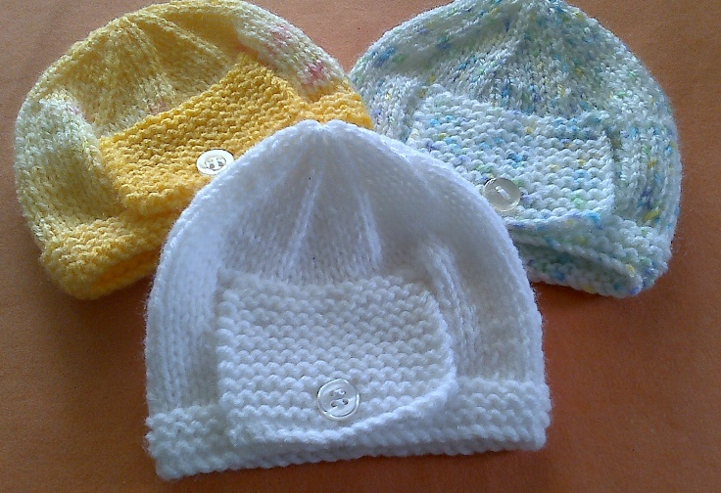Using 3.25mm needles, cast on 15 sts work 2 rows garter stitch.

Next row: K7 YFW K2tog, K6 (Buttonhole row)

Work 16 rows in garter stitch

Next row: K2tog, K3, K1 K2tog, K3, K2tog

Leave sts on needle (11 sts)

Using 3.25mm needles, cast on 53(61, 69, 77, 85) sts

Work 6 rows in garter stitch

Work in stocking stitch for 2(4,4,6,8) rows

Next row: K21(25,29,33,37). Cast off 11 sts, K20(24,28,32,36)

1st row Purl across 21(24,28,32,36)sts, K last 2 sts

2nd row Knit

Repeat 1st and 2nd rows 5 times more then lst row once. Leave on needle.

3rd row K2 P to end

4th row Knit. Repeat 3rd and 4th rows 5 times more then the first row once.

Nexr row: Knit across 21(25,29,33,37)sts. Knit across flap (11sts) then across the 21(25,29,33,37) sts on needle. 53(61,69,77,85) sts

Next row: Purl across all sts.

Work 2(4,4,6,8) rows in stocking stitch

Next row: K7(7,8,9,9,) sts *K2tog, K5* repeat from * to * to last 2 sts K

Next and every alternate row: Purl

Next row: K6(6,7,8,8) sts *K2tog, K4* repeat from * to * to last 2 sts K

Next row: K5(5,6,7,7,)sts *K2tog, K3* repeat from * to * to last 2 sts K

Next row: K4(4,5,6,6,)sts *K2tog, K2* repeat from * to * to last 2sts K

Next row: K3(3,4,5,5,)sts *K2tog, K1* repeat from * to * to last 2 sts K

Next row: K2tog repeat to end

Break off wool and run wool through sts. Draw up and sew up all the way down the back of cap

Sew on button to correspond to buttonhole in flap.